Transcripts

Via computer
Step 1: Go to: https://jefferson-lehigh.cloud-cme.com

Step 2: Click Sign In, and sign in using your email address and password.

Step 3: Click the My CME or My CE button.

Step 4: Click Transcript

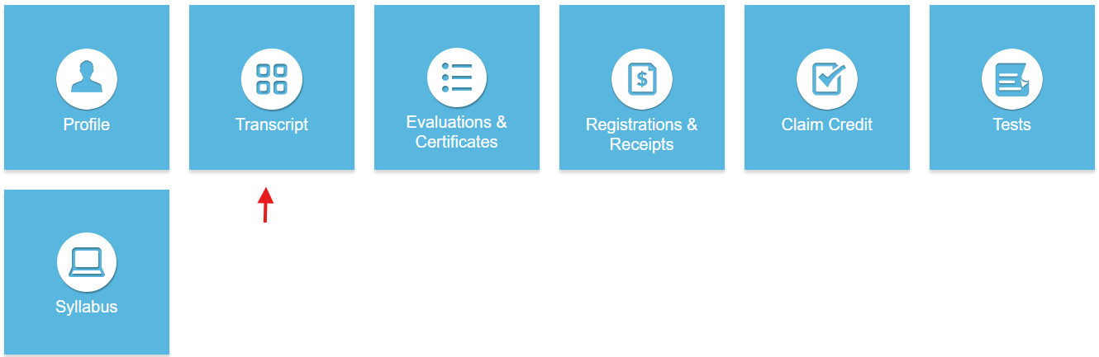

Step 5: Select a date range for the transcript records you wish to access by entering in a Start and End Date or filter transcripts by credit type. You can also email or download your transcript.

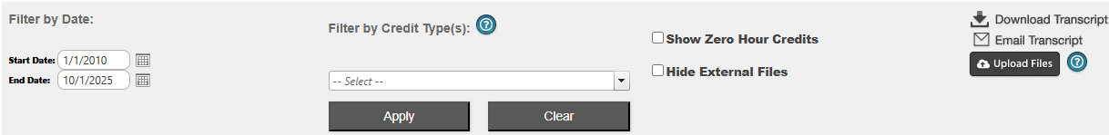

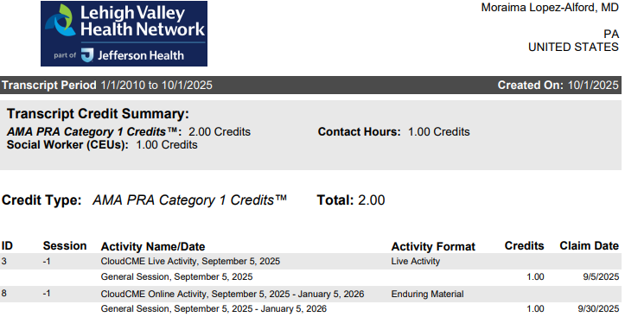

Step 6: You can upload a transcript for activities that you completed outside of your organization by clicking the Upload Files button and selecting the file you wish to add to your CloudCMEâ transcript. The appended transcript will display at the end of your CloudCMEâ transcript.

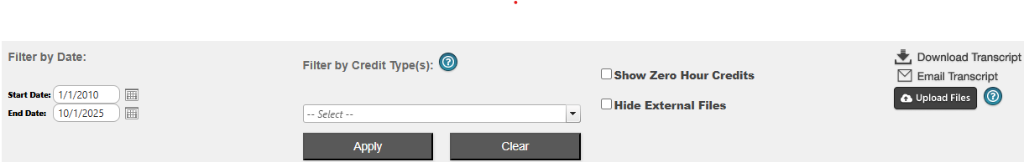
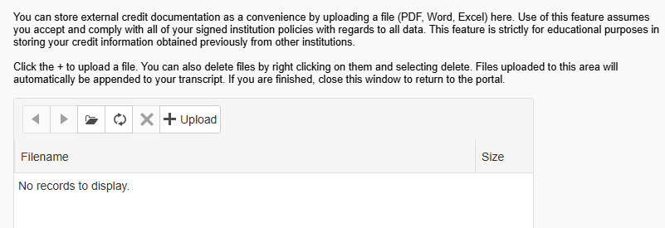

Via CloudCME App
Step 1: Open the CloudCME Mobile App.
Step 2: Login using your email address and password.
Step 3: Select My Transcript on the menu.
Step 4: Select “View,” “Email” or “Save to My Device” depending on the action you wish to take.

